**Supply Chain Management**

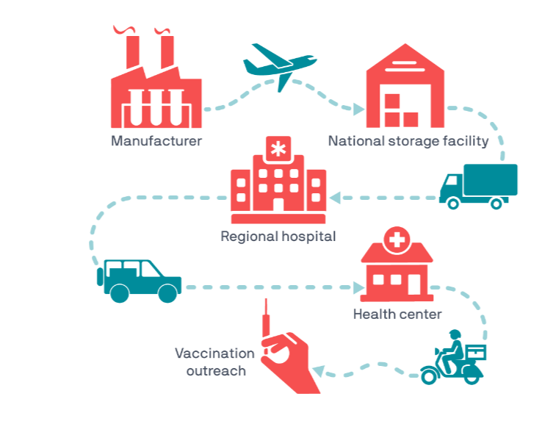

System Actors

1. **Manufacturer**
   * process raw materials into vaccines
2. **Distributor**
   * transports vaccines between locations
3. **Inspector**
   * performs quality checks on vaccines
   * performs quality checks on manufacturing plants
4. **Storage Facility**
   * store vaccines in cold temperatures
5. **Immunizer** (the doctors, nurses
   * vaccinates people
   * provides vaccine passport/certificates
6. **Traveller** (the patient)**:**
   * receives vaccine
   * receives vaccine certificate
   * presents vaccine certificate at the border of the destination country
7. **Border Agent**
   * verifies the vaccine certificates/passports

**Output :-**

